

**Activity 9.**

**Download the following** [**worksheet [Click here]**](https://drive.google.com/file/d/11KLV2cgTJuHmRNm3WvuyjMF6pQDEWx6v/view?usp=sharing) **and use your knowledge about question words to solve the exercises. To check the rubric for this** [**assignment [Click here].**](https://drive.google.com/file/d/1HFXheniOcF-Oy9x4jxP0txR0TtSITmYL/view?usp=sharing)

**You can either print and write on the worksheets or you can use an editor to write your answers using the computer.**

**References:**

**Murphy, R. and Čhakramāt, S., 2002. *Essential grammar in use* (Vol. 20010). Cambridge University Press. [Pp. 100 - 105]**

## Who saw you? Who did you see?

**4 5** (questions 2)

, *SILVIA*

*subject*

Somebody saw Paul.

W ho saw Paul? Silvia. (Silvia saw him.)

**who** is the *subject*

**Paul** is the *object*

*PAUL* !

Silvia saw Paul

Silvia saw Paul.

W ho **saw** Paul?

Silvia. (Silvia saw him.)

Who **did** Silvia **see?**

Paul. (She saw Paul.)

*object*

i

Silvia saw somebody .

!

W ho did Silvia see?

Paul. (She saw Paul.)

**who** is the *object*

**Silvia** is the *subject*

In these questions, **who/what** is the *subject:*

O **Who lives** in this house? (= somebody lives in it - who?)

*(not* W ho does live?)

O **What happened?** (= something happened - what?)

*(not* W hat did happen?)

O **What's happening?** (What's = W hat **is) O Who's got** my key? (Who's = W ho **has)**

In these questions, **who/what** is the *object:*

O W ho did **you** meet yesterday? (= **you** met somebody - who?)

O W hat did **Paul** say? (= **Paul** said something - what?)

O Who are **you** phoning?

O What was **Silvia** wearing?

Compare:

O George likes oranges. O Jane won a new car.

**Who likes** oranges? - George.

**What** does George like? - Oranges.

**Who won** a new car? - Jane.

**What** did Jane win? - A new car.

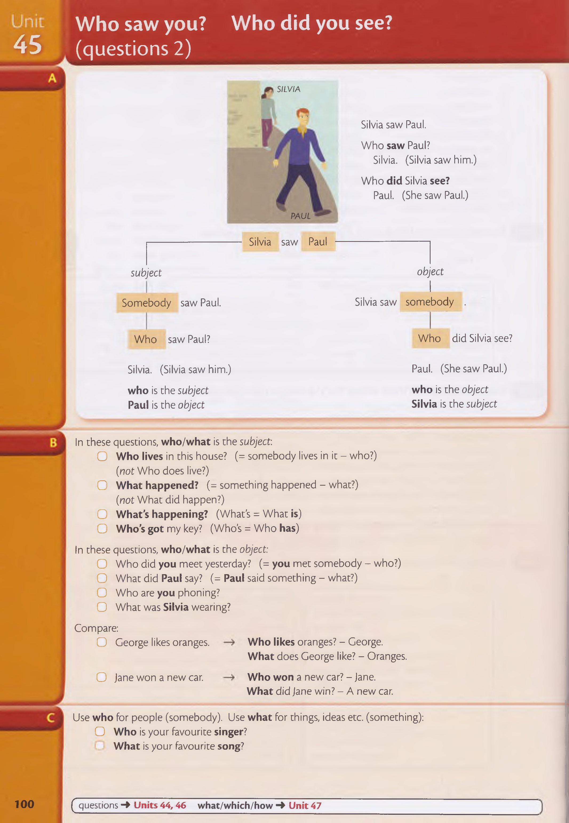Use **who** for people (somebody). Use **what** for things, ideas etc. (something):

O **Who** is your favourite **singer? What** is your favourite **song?**

**100** ( questions **-> Units 44,46 what/which/how -> Unit 47**

## Exercises

**Make questions with who or what. In these questions, who/what is the subject.**

fell off the shelf?

Who wants to see

Who took my umbrella?

Who made me ill?

Who is coming?

**Make questions with who or what (subject or object). 1**

### 2

Who did you phone?

3

What happened last night?

4

Who knows the answer?

5

Who did the washing-up?

6

What did Jane do?

7

What woke you up?

8

Who saw the accident?

9

Who did you see?

10

Who has got your pen?

11

What does this word mean?

12

#### You want the missing information (XXXXX). Write questions with who or what.

V s . / £ .

I lost **XXXXX** yesterday, but fortunately

**XXXXX** found it and gave it back to me.

..What djd you Jose?.. Who found it?

did she want?

phoned you last night?

**XXXXX** phoned me last night. She wanted

#### XXXXX.

W h o ... W hat.

What did she tell you?

Who did you meet on your way home?

Who won the game?

Who told you?

Who got married last week?

What did he say?

Who did you ask for advice?

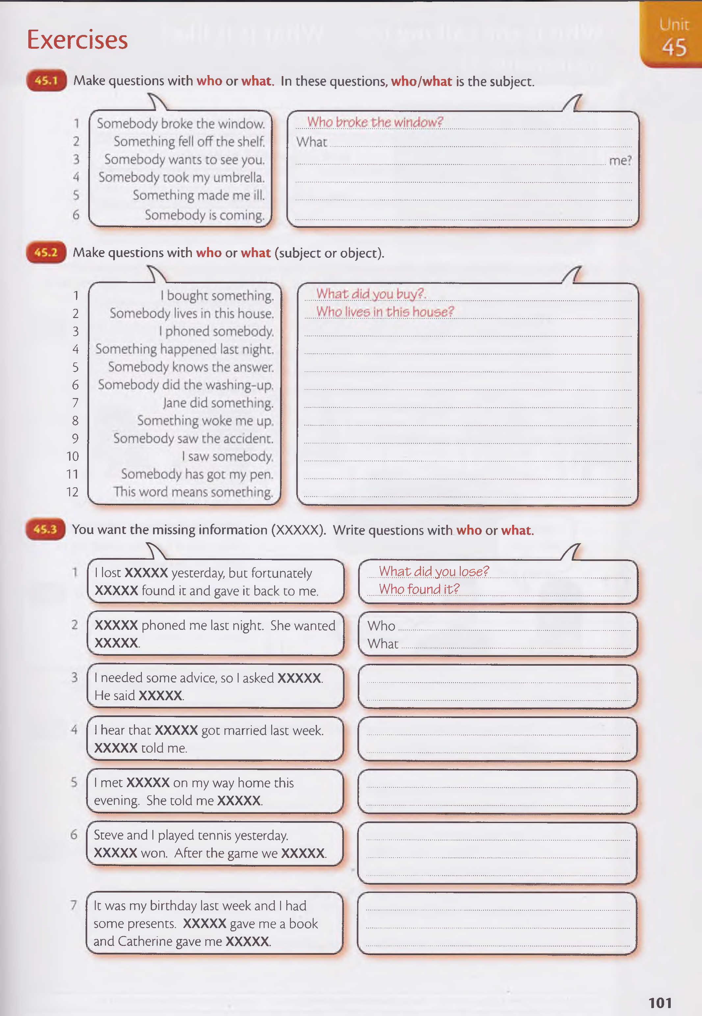

What did you do after the game?

I needed some advice, so I asked **XXXXX.**

He said **XXXXX.**

Who gave you a book?

I hear that **XXXXX** got married last week.

What did Catherine give you?

**XXXXX** told me.

I met **XXXXX** on my way home this evening. She told me **XXXXX.**

## Unit Who is she talking to? What is it like?

**4 6** a (questions 3)

Jessica is talking to somebody.

**Who** is she talking **to?**

In questions beginning **Who** *.. .I I* **W h a t...** ? / **Where ... ? / Which** ... ?, prepositions **(to/from/with**

etc.) usually go at the end:

O **'Where** are you **from?'** 'I'm from Thailand.' O 'Jack was afraid.' **'What** was he afraid **of?'**

O **'Who** do these books belong **to?'** 'They're mine.'

O 'Tom's father is in hospital.' **'Which hospital** is he **in?'**

O 'Kate is going on holiday.' **'Who with?' / 'Who** is she going **with?'**

O 'Can we talk?' 'Sure. **What** do you want to talk **about?' What's it like? / What are they like?** etc.

What's it like? = What is it like?

**What's it like?** = tell me something about it - is it good or bad big or small old or new (etc.)?

very big. ^

When we say **'What is it like?' like** is a *preposition.* It is not the verb **like ('Do** you **like** your new house?' etc.).

O a: There's a new restaurant in our street.

b: **What's** it **like?** Is it good?

a : I don't know. I haven't eaten there yet.

**o** a : **What's** your new teacher **like?**

b: She's very good. We learn a lot.

O a : I met Nicola's parents yesterday.

b: Did you? **What** are they **like?**

a : They're very nice.

O a : Did you have a good holiday? **What** was the weather **like?**

b: It was lovely. It was sunny every day.

( questions 1-2 **Units 44-45 what/which/how Unit 47** prepositions **4 Units 103-113**

# Exercises

#### You want the missing information (XXXXX). Write questions with who or what.

1. **(** T^e leccer is from **XXXXX.)....(** .... W h o js th e le ffie rfro m ? **^**

looking for

are

1. ( I'm looking for a **XXXXX.)** ( w h a t ......................... yo u I)
2. f l went co che cinema wich **XXXXX.)** f **)**

Who was the book written by?

What was the film about?

Who did you go to the cinema with?

1. ( The fi Im was about **XXXXX.) (** I)

Who did you give the money to?

#### ( I gave the money to XXXXX.) ( ..............................................................................................

1. f The book was written by **XXXXX.~)** (* J l

#### 1 ^ 3 1 Write questions about the people in the pictures. Use these verbs + a preposition: go listen look talk talk wait

It was vary *good*

is she listening?

are they talking?

are you waiting for?

is he going to?

looking?

are

1. W ho js.she M lklna.to? 4 W h a t ............
2. W h a t ................... th ey............................................................ 5 W h a t.............
3. Which restaurant................................................................ 6 Which bus.

Wich hotel did

stay at?

#### Write questions beginning Which ... ?

Which school did you go to in this town?

Which team does Jack play for?

What are the roads like?

What are the people like?

What is the weather like?

**^ 2201 Y ° u want some information about another country. You ask somebody who has been there. Ask questions with What is/are ... like?**

1. (the roads) ............................................................................................................................
2. (the food)

What were the lessons like?

What was the hotel like?

What was the film like?

Unit **What...? Which...? How...?**

# **47** (questions 4)

**What** + *noun***(What colour ... ? / What kind** ... ? etc.)

**What colour** is your car? **What colour** are your eyes?

**What size** is this shirt? O **What make** is your TV?

**What time** is it? O **What day** is it today?

**What kind** of job do you want?

*(or***What type** of job ... ? / **What sort** of job ... ?)

**What** without a noun:

**What's** your favourite colour?

**What** do you want to do tonight?

**Which** + *noun* (things or people):

**Which train** did you catch - the 9.50 or the 10.30?

**Which doctor** did you see - Doctor Ellis, Doctor Gray or Doctor Hill?

We use **which** without a noun for things, not people:

**Which** is bigger - Canada or Australia?

We use **who** for people (without a noun):

**Who** is taller - Joe or Gary? *(not* Which is taller?)

**What** or **which?**

We use **which** when we are thinking about a small number of possibilities (perhaps 2, 3 or 4): O We can go this way or that way.

**? 7 7 7**

**Which way** shall we go? There are four umbrellas here. **Which** is yours?

**What** is more general:

or or or

• • • •

W HICH?

**What's** the capital of Argentina? (of all the cities in Argentina)

**What sort** of music do you like? (of all kinds of music)

Compare:

**What colour** are his eyes? *(not* Which colour?)

**Which colour** do you prefer, **pink or yellow?**

**O What** is the longest river in the world?

**Which** is the longest river - **the Mississippi, the Amazon or the Nile?**

#### H o w . .. ?

O **'How** was the party last night?' 'It was great.' O **'How** do you usually go to work?' 'By bus.'

You can use **how** + *adjective/adverb* **(how tall / how old** / **how often** etc.):

**tall** are you?' 'I'm 1 metre 70.' **big** is the house?' 'Not very big.' **old** is your mother?' 'She's 45.'

#### How

**far** is it from here to the airport?' 'Five kilometres.'

**often** do you use your car?' 'Every day.' **long** have they been married?' 'Ten years.' **much** was the meal?' 'Thirty pounds.'

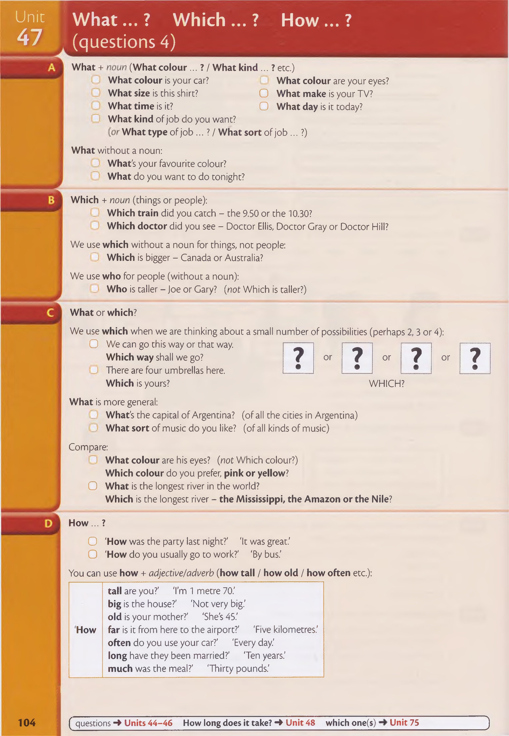**104** ( questions 4 **Units 44-46 How long does it take? ->• Unit 48 which one(s) Unit 75** 3

# Exercises

#### Write questions with what.

*r* \ N a

1. I've got a new TV. (make?)
2. 1 want a job. (kind?)

coulour is it?

1. 1 bought a new sweater. (colour?)

What time did you

1. 1 got up early this morning. (time?)

What type of music do you like?

1. 1 like music. (type?)

What kind of car do you want?

want to buy a car.

1

6

V 7 *J*

Jkin d ?)

#### Complete the questions. Use Which ... ?

Which one

Which bus

Which cinema

Wich

**C B 9 Write what/which/who.**

1. W hat is that man's name?
2. Which.....way shall we go? Left or right?

Who

Wich

What

1. You can have tea or coffee............................ do you prefer?

What

1. '.......................day is it today?' 'Friday.'
2. This is a nice office desk is yours?

How long

How deep

How often

How old

How far

1. is your favourite sport?

How heavy is this box?

How old are you?

How much did you spend?

1. ....................... is more expensive, meat or fish?

Who

1. is older, Liz or Steve?

What

1. kind of camera have you got?

Wich

What

1. **a :** I have three cameras.

**b:** camera do you use most?

1. nationality are you?

How often do you watch TV?

How far is it from Paris to Moscow?

How tail are you?

1. 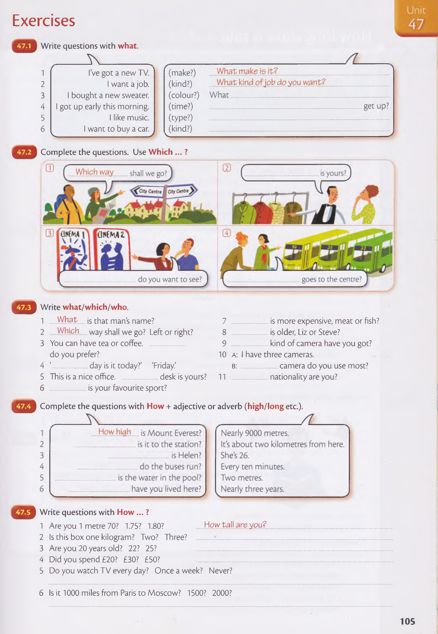Is this bo